Assessment Schedule – 2016

Chemistry: Demonstrate understanding of the properties of selected organic compounds (91165)

Evidence Statement
Q | Evidence | Achievement | Merit | Excellence
ONE  (a) (i)  (ii) | 2-iodohexane  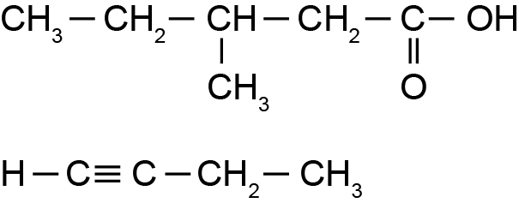  propan-1-amine (1-propanamine)  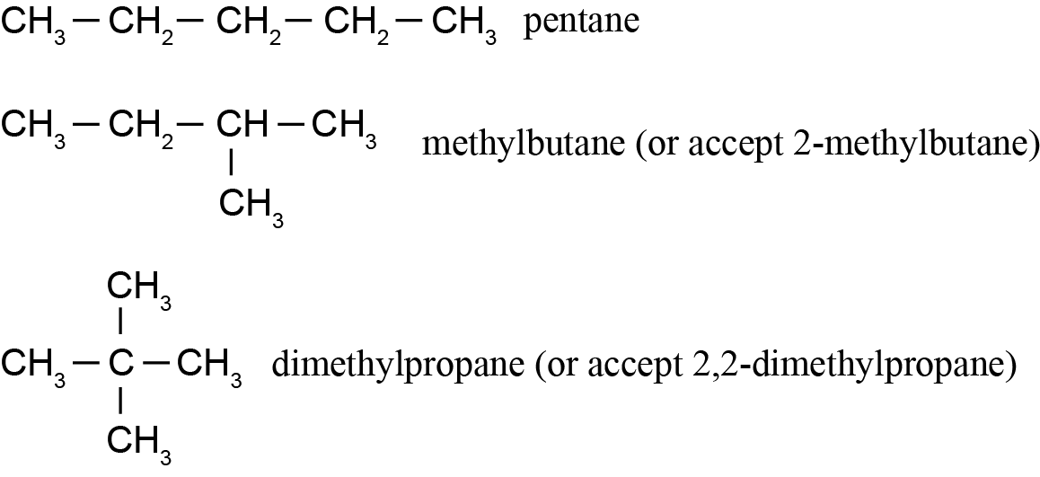 | - Any FOUR structures or names correct. | - Any NINE structures and names correct.
(b)(i)  (ii) | A. Tertiary (or 3º)  B. Primary (or 1º)  C. Secondary (or 2º)  Classifying haloalkanes as primary, secondary, or tertiary requires counting the number of C or H atoms bonded to the C atom to which the halogen is attached.  If the C atom bonded to the halogen has 3 other carbon atoms (or 0 H atoms) bonded to it, the haloalkane is a tertiary (3º) alkane. | - All THREE classifications correct.  - States how to classify haloalkanes correctly. | - Links how to classify haloalkanes correctly to structure A in the table.
(c)(i)  (ii) | A. trans  B. cis  1,2-dibromoethene can form cis and trans isomers because it has a double bond. The double bond between two carbon atoms does not allow any rotation of atoms around it.  As well as the double bond, the C atoms directly attached to it must have two different atoms or groups attached to them. For 1,2-dibromoethene, both the C atoms on the double bond have an H and a Br atom bonded to them.  When these two requirements are met, two alkenes can have the same molecular formula and the same sequence of atoms in the formula, but a different arrangement in space (a different 3D formula), hence they are cis and trans isomers. | - Correctly identifies both cis and trans isomers,  AND  EITHER  States that a rigid double bond is needed.  OR  Each carbon around the double bond needs TWO different atoms or groups attached to it. | - Explains why the double bond is required for cis and trans isomerism.  OR  Explains why each C atom on the double bond must have two different atoms or groups attached to them. | - Explains why the double bond and two different atoms or groups of atoms on the C atoms of the double bond are required for cis and trans isomers.  AND  Relates their answer specifically to the example given in the question.

NØ | N1 | N2 | A3 | A4 | M5 | M6 | E7 | E8
No response; no relevant evidence. | 1a | 2a | 3a | 4a | 2m | 3m | 1e  OR  1e (with minor error or omission) + 1m | 1e + 1m

Q | Evidence | Achievement | Merit | Excellence
TWO  (a)(i)  (ii) | The boiling points of both alkanes and alcohols increase as the number of C atoms increases. The boiling points of alcohols are always higher than the alkanes (with the same number of C atoms).  Alkanes with 1, 2, 3, and 4 C atoms (methane, ethane, propane, and butane) will be gases at room temperature. | - Correctly identifies one trend.  OR  Correctly identifies all four gaseous alkanes. | - Both trends identified. AND  All four gases named.
(b)(i)  (ii) | CH₃CH₂NH₂(aq) + HCl(aq) → CH₃CH₂NH₃⁺(aq) + Cl–(aq) OR CH₃CH₂NH₃Cl(aq)  Carboxylic acids have acidic properties because when they react, some of the acid molecules donate H⁺ to water molecules.  CH₃COOH(aq) + H₂O(l) → CH₃COO–(aq) + H₃O⁺(aq) | - Completes a balanced equation correctly.  - Identifies H⁺ is transferred from ethanoic acid to water molecules.  OR  Identifies H⁺ / H₃O⁺ as a product of the reaction.  OR  Identifies an acidic property, e.g. indicator, neutralisation reaction. | - Explains why carboxylic acids have acidic properties, e.g. donates a proton to water / produces hydronium ions.  AND  Writes a balanced equation for a reaction.
(c) | Ethane is an alkane which will react slowly with bromine water, Br₂(aq), if (UV) light (or heat) is present, whereas the reaction between ethene and bromine water is immediate, and requires no special conditions.  When they react, both ethane and ethene cause orange / yellow bromine water to decolourise.  Since ethane is already a saturated molecule / hydrocarbon, it undergoes substitution with bromine water, resulting in the formation of bromoethane, CH₃CH₂Br. Ethene, however, is an unsaturated molecule / hydrocarbon, because it has a double C=C bond, which breaks, allowing two extra atoms to bond to the structure, resulting in the formation of 1,2-dibromoethane, CH₂BrCH₂Br. This is an addition reaction. | - Identifies conditions and observations for one reaction.  OR  Both structures correct.  - Identifies both types of reaction correctly. | - Links conditions, observations, reaction type, and structural formula of product for one or both reactions.  (Does not ‘compare and contrast’.) | - Compares and contrasts both reactions comprehensively.

NØ | N1 | N2 | A3 | A4 | M5 | M6 | E7 | E8
No response; no relevant evidence. | 1a | 2a | 3a | 4a | 2m | 3m | 1e  (minor error/omission) | 1e

Q | Evidence | Achievement | Merit | Excellence
THREE  (a)(i)  (ii) | Compound A. CH₃─CH₃  Compound B. CH₃─CH₂OH  Compound C. CH₃─COOH or CH₃─COH (aldehyde)  Reagent X. concentrated H₂SO₄  Reaction 1: substitution  Reaction 2: substitution  Reaction 3: oxidation | - Any THREE correct in (a)(i).  OR  All THREE correct in (a)(ii). | - Any SIX correct.
(b)(i)  (ii) | 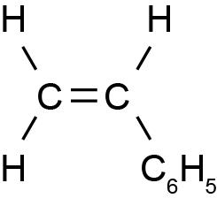  Since the monomer for this reaction, styrene, is an alkene, when polymerisation occurs, the double bond in each styrene molecule is broken, freeing up a bonding space on each of the C atoms that was part of the double bond. This allows the monomers to join together by forming covalent bonds to make polystyrene.  Since double bonds in styrene are being broken and molecules added into the freed up bonding spaces to make polystyrene, this is an addition reaction.  Polymerisation reactions occur when many monomers are chemically joined. | - Correct monomer is drawn.  - Correctly states why this is an addition reaction. | - Links how the polymer forms to why it is an addition reaction.
(c)(i)  (ii) | 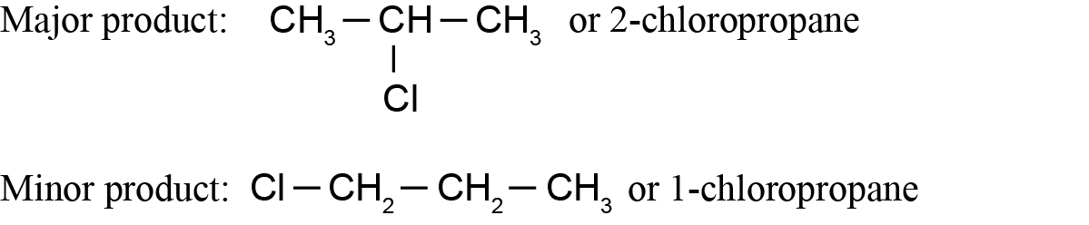  Two products are formed in this reaction because propene is an asymmetric alkene. When another asymmetric molecule such as hydrogen chloride, HCl, is added to it, there are two possible products. One product is produced in greater quantities (the major product) than the other (minor product).  The rule for determining which is the major product (called the Markovnikov’s rule) states that the C in the double bond with the most H atoms directly attached to it is most likely to gain another H atom (‘rich get richer’ concept).  The most common product, the major product, is therefore 2-chloropropane, and  1-chloropropane is the minor product.  (The term Markovnikov’s rule is not required.) | - Both major and minor products are correct (indicated by either structure or name).  OR  States the definition of Markovnikov’s rule (NOT just the ‘rich get richer’).  OR  Identifies propene as an asymmetric alkene. | - Explains why there are two products formed in this reaction.  OR  Explains why  2-chloropropane is the major product.  OR  Explains why  1-chloropropane is the minor product. | Elaborates on the reaction by explaining why two products form and how the major and minor products are determined.

NØ | N1 | N2 | A3 | A4 | M5 | M6 | E7 | E8
No response; no relevant evidence. | 1a | 2a | 3a | 4a | 2m | 3m | 1e  OR  1e (with minor error or omission) + 1m | 1e + 1m

Cut Scores
Not Achieved | Achievement | Achievement with Merit | Achievement with Excellence
0 – 7 | 8 – 14 | 15 – 18 | 19 – 24

